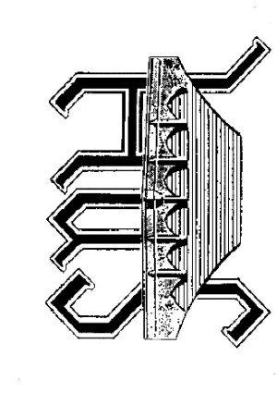

Sturminster Newton Heritage Trust

Membership Application Form (Revised October 2019)

Contact :- snmmsociety@outlook.com or via our website

www.sturminsternewton-museum.co.uk
Annual Subscription
Ordinary membership: - £8.50
£100.00 or more entitles the Donor to Life Membership.
( Annual subscriptions are normally paid at the time of the AGM in November of each year and may be paid by Bankers Order. Bankers Order Instructions are provided at the bottom of this page for future subscription payments ).
I / We enclose £………..
NAME(S) …………………………………………………………………………………………….
ADDRESS (with postcode)…………………………………………………………………………
…………………………………………………………………………………………………………..
TELEPHONE NO …………………………………………………………………………………….
E-MAIL ADDRESS ( For newsletters and lecture programmes )

………………………………………………………………………………………………………………………
I would / would not like to help with stewarding at the Mill / Museum On a regular basis / On a backup panel
On a regular basis / On a backup panel
I may be able to assist the Mill & Museum in other ways (please give examples)
SIGNATURE(S) & DATE
………………………………………………………………………………………………………………………

Please return to the Treasurer: - Richard Brown, Squirrel Bank, Upland Close, Broad Oak, Sturminster Newton DT10 2HL or to any other member of the SNMMS.

Signing this application for Membership of the Trust signifies that you freely give consent to your name and other details you have given being held on an electronic or other database for the purpose of the Trust’s administration and for communicating to you by post, telephone or email. Your details will not be passed on to any other organisation without your written permission. Our privacy policy can be viewed in the Museum or Mill.
It would help us and you if you paid your subscription by an annual bankers order. If you agree please fill in the form below and either send this part to your bank or leave it for us to do.

BANKERS ORDER

To ( Name & Address of your bank )………………………………………………………………
Amount in words
for the credit of : - STURMINSTER NEWTON HERITAGE TRUST
A/C 32849060, Lloyds Bank PLC. Sort Code : - 30 - 90 – 92.
£ … ( Amount in words …………………..)
on the day of 20

and the same day each year until further notice.
Signature Date
Name of Account (Block Capitals)
Account No Sort Code - -
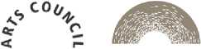

Registered Charity No: 1184320
Stixminwer Mrwton

. ACCREDITED
MUSEUM

